**Aroga A1C Lab Results Analytics**

1. Looking at every patient in the A1C dataset, most patients have a lower A1C level in their latest lab test when compared with their first lab test.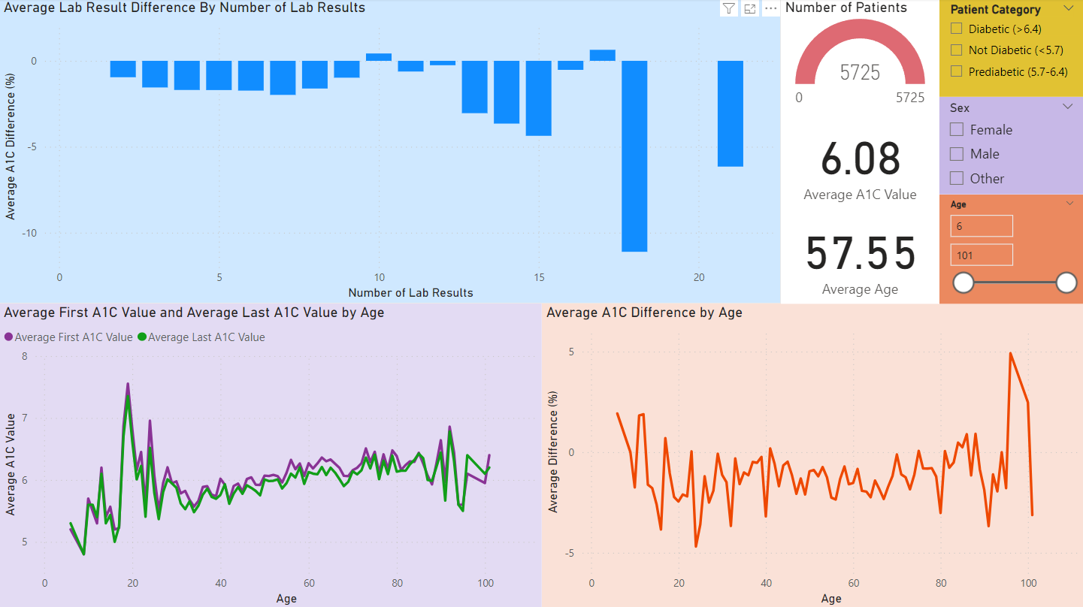(Report 1: All Patients)
2. The majority of patients are ages over 50. Younger patients between the ages 18 to 25 have significantly higher A1C levels than the rest of the dataset. However, patients under 40 have a larger negative A1C difference between their first lab result and last compared to patients over 40.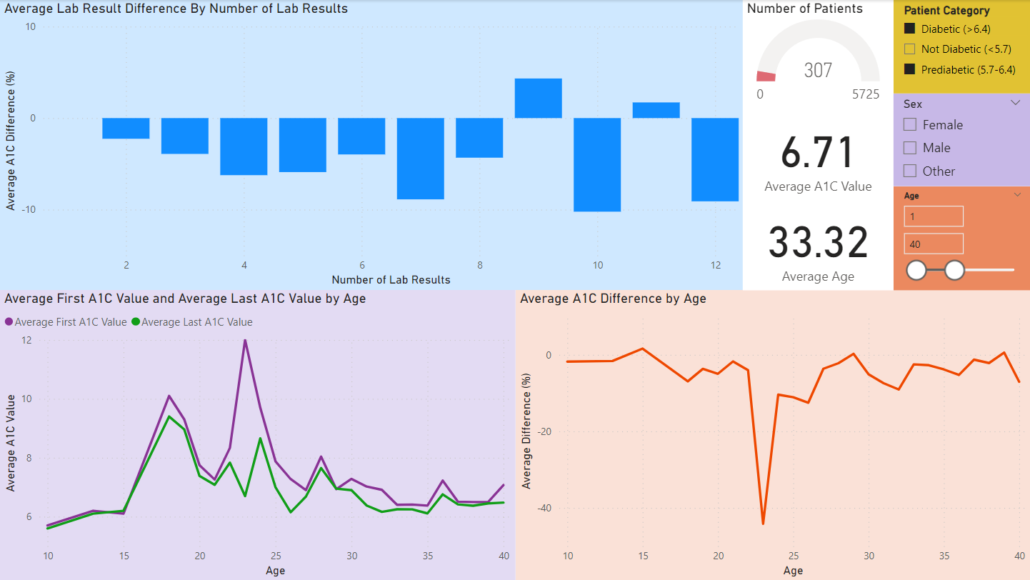(Report 2: Diabetic or Prediabetic Patients Under 40)

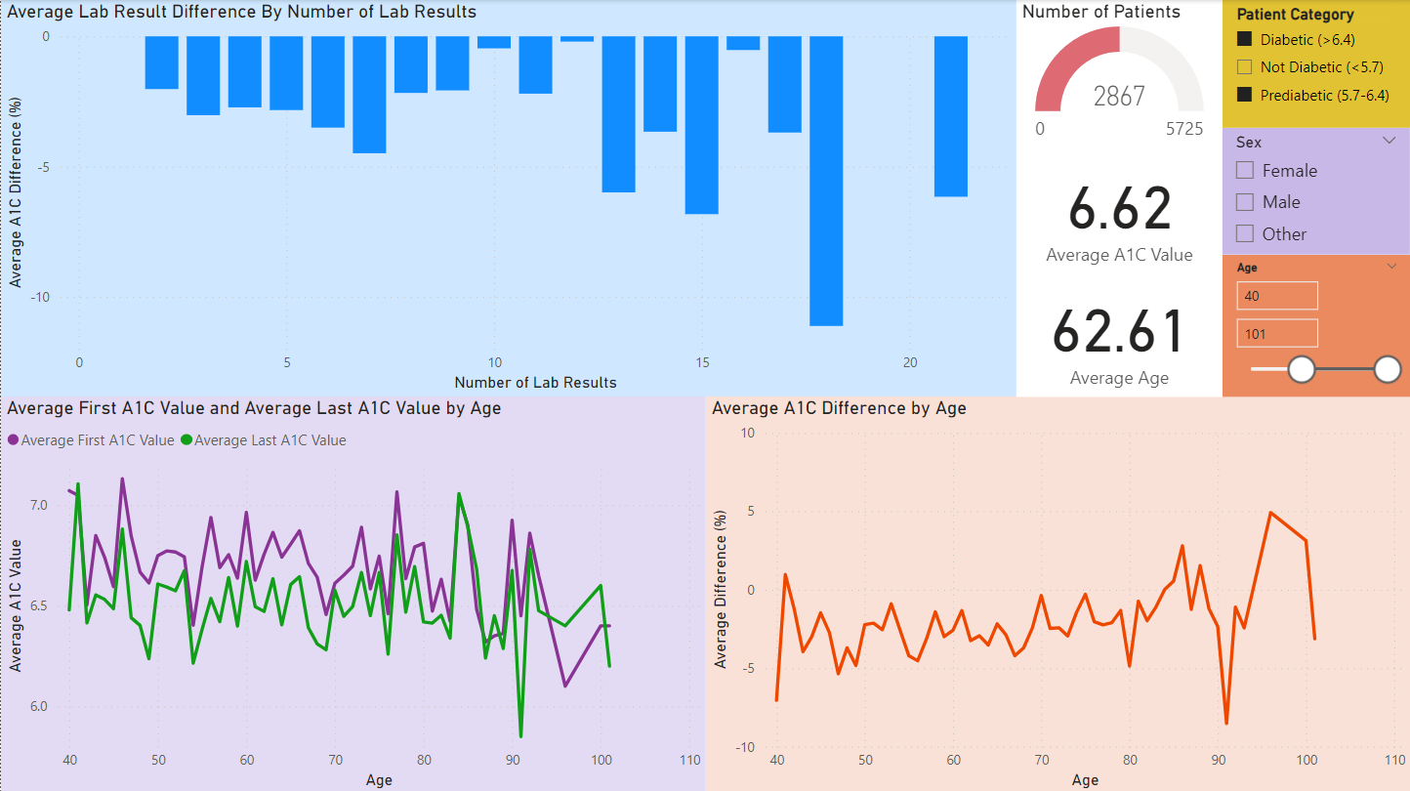(Report 3: Diabetic or Prediabetic Patients Over 40)

1. 45% of patients that do their first A1C test are below prediabetic A1C levels.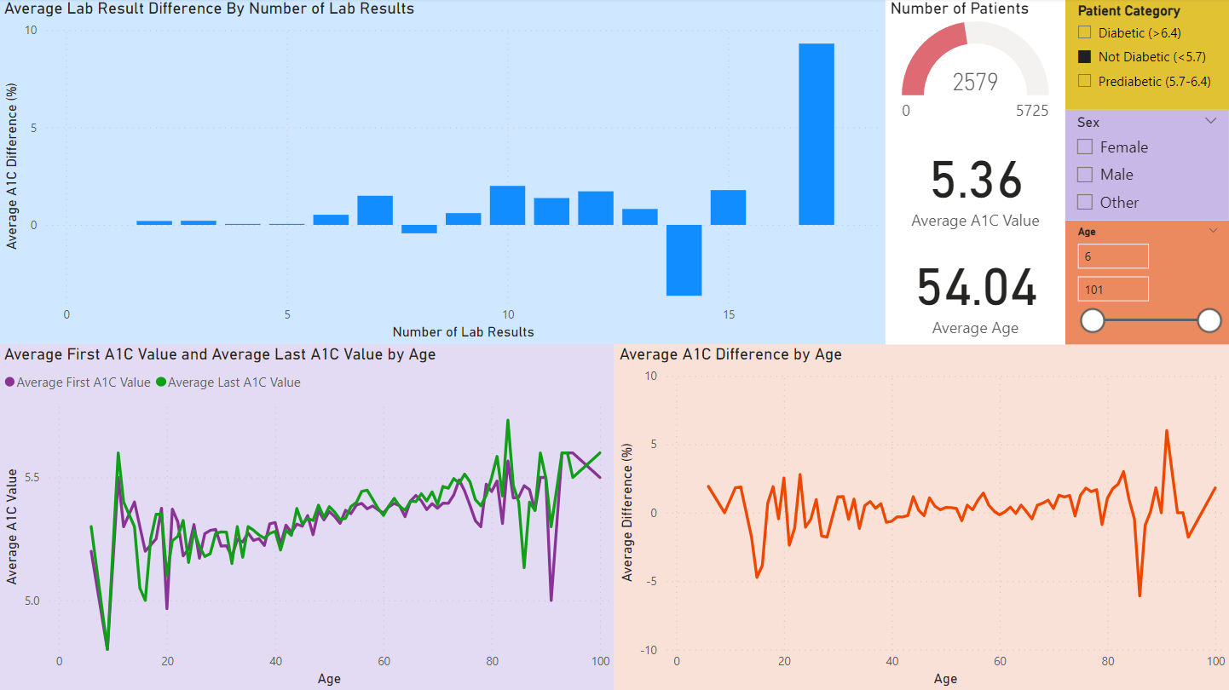

(Report 4: All Non Diabetic Patients)